#### TRAFFIC MANAGEMENT SYSTEM

**IOT_Phase4**

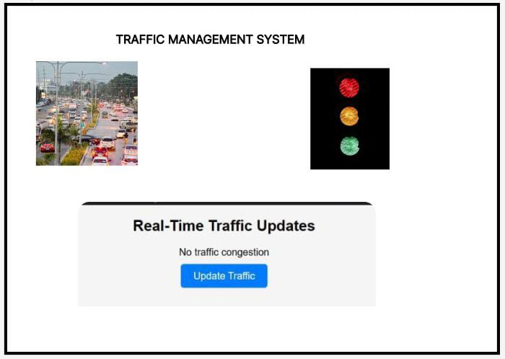

**DESCRIPTION**

*The traffic management system is used to find the road congestion

*It is used to avoid traffic

*It is used for ambulance road clearance

**HTML CODES**

<!DOCTYPE html>

<html>

<head>

<title>Real-Time Traffic Updates</title>

</head>

<body>

<div class="traffic-container">

<h2>Real-Time Traffic Updates</h2>

<p id="traffic-data">Loading...</p>

<button class="btn" id="update-btn">Update Traffic</button>

</div>

</body>

</html>

**CSS CODES**

/* CSS for traffic information container and controls */

.traffic-container {

width: 500px;

margin: 0 auto;

padding: 20px;

background-color: #f5f5f5;

border-radius: 10px;

text-align: center;

font-family: Arial, sans-serif;

}

.traffic-container h2 {

margin-top: 0;

}

.traffic-container p {

margin-bottom: 0;

}

.btn {

margin: 10px;

padding: 10px 20px;

font-size: 16px;

cursor: pointer;

background-color: #007bff;

color: #fff;

border: none;

border-radius: 5px;

text-decoration: none;

}

**JAVA SCRIPT**

// JavaScript code to fetch and display traffic information

const trafficDataElement = document.getElementById("traffic-data");

const updateBtn = document.getElementById("update-btn");

function fetchTrafficData() {

// Simulating API call to fetch traffic data

setTimeout(() => {

// Generate random traffic data

const trafficInfo = Math.random() < 0.5 ? "No traffic congestion" : "Heavy traffic congestion";

// Update the traffic data element with the received data

trafficDataElement.textContent = trafficInfo;

}, 2000);

}

// Call fetchTrafficData initially

fetchTrafficData();

// Add click event listener to update button

updateBtn.addEventListener("click", function() {

trafficDataElement.textContent = "Loading...";

fetchTrafficData();

});

## CIRCUIT

